SmartLine® Controllers
SL4800
SL4800 CONTROLLER(S) shall be model SL4800 as manufactured by Weathermatic Sprinkler Division of Telsco Industries, or approved equal. Controller(s) shall be a four (4) program controller with hot swappable 12-zone modules to allow expansion to 48 zones.

OPERATION: Controller shall be capable of standard timed watering or auto adjust watering times when equipped with an optional SLW weather monitor manufactured by Weathermatic. Auto Adjust watering shall be based on real time, on-site weather data and system audit data entered by the user. Auto adjust timing shall be based on the Hargreaves ET calculation formula. Controller shall provide reviewable watering deficits, scheduled run times by zone and a total run time recap for each zone which is resettable by the user. A more or less function shall be provided to allow run time adjustment by zone for shade/sunlight, system efficiency and other local factors. Auto adjust mode shall also include automatic calculation of run/soak times based on both soil type and zone elevation.

Each program shall have eight independent start times, calendar schedules, watering budgets by month and a soak/cycle for varying soil percolation rates.

Controller shall have a pump start/master valve position which shall be programmable to operate on demand from any selected zone. A programmable safety delay shall be included for zone to zone delay and master valve to zone delay for opening and closure.

Controller shall have input for rain and freeze sensor devices. Use of the optional SLW weather monitor shall incorporate the rain and freeze shutdown functions and shall incorporate a 48 hour delay after closure of the rain sense switch.

Controller shall have self-diagnostic capabilities to detect “short” or “open” zones and the ability to display lists of faults on an LCD display for the user. Diagnostics shall also include LCD display of volt/amp readings by zone and for transformer output as well as backup battery reading. A chatter function shall also be provided to assist in locating buried valves. The controller shall automatically prevent master valve opening or pump start when the valve locator diagnostic is used.

Display shall be backlit for clear viewing in all lighting conditions. Zone timing shall be settable from 1 minute to 9 hours and 55 minutes.

Program D shall operate concurrently with programs A, B and C. Programs A, B and C shall stack in sequence of start time operation.

Program schedules shall include options for days of the week, odd date, even date or an interval of 1 to 30 days. A ‘no water’ window shall be available to inhibit daily operations of a program between two selected times on a given day; omission of up to 7 specified calendar dates or specific days of the week. Adjustments for leap year shall be automatic.

Manual operation shall be provided by program, by station, or on a programmable test program with durations from ten (10) seconds to ten (10) minutes. The programmable test program shall also check for short and open conditions on each zone each time it is run.

Non-volatile memory shall retain all programming and real-time clock shall be provided to maintain date and time.

CONSTRUCTION: Controller shall be enclosed in a U.L., CE and C-Mark Listed rainproof plastic enclosure with optional key lock. The enclosure shall be rated for outdoor or indoor use. Enclosure shall be a wall mount (pedestal mount) model with removable knockouts on the lower side and back of the housing for choice of wiring location. The operating panel shall be a totally enclosed module that is removable from the housing for programming at a separate location. A test post for 24V a.c. operation shall be accessible with or without the operating panel. Zone modules (SLM4) shall be self-contained modules that can be installed without turning off power to the unit and programming of new zones shall not be required. Module wiring connections shall be of the type that allows insertion of solid wires without any tool. Each module shall contain its own surge protection.

ELECTRIC: Controller shall be completely electric in operation. Controller shall be installed and wired in accordance with manufacturer’s published instructions. Controller shall be capable of operating from an independent power supply. Primary shall be 115V a.c. 60hz or 230V, 50hz.

WARRANTY: Controller shall have a manufacturer’s limited warranty of three (3) years.
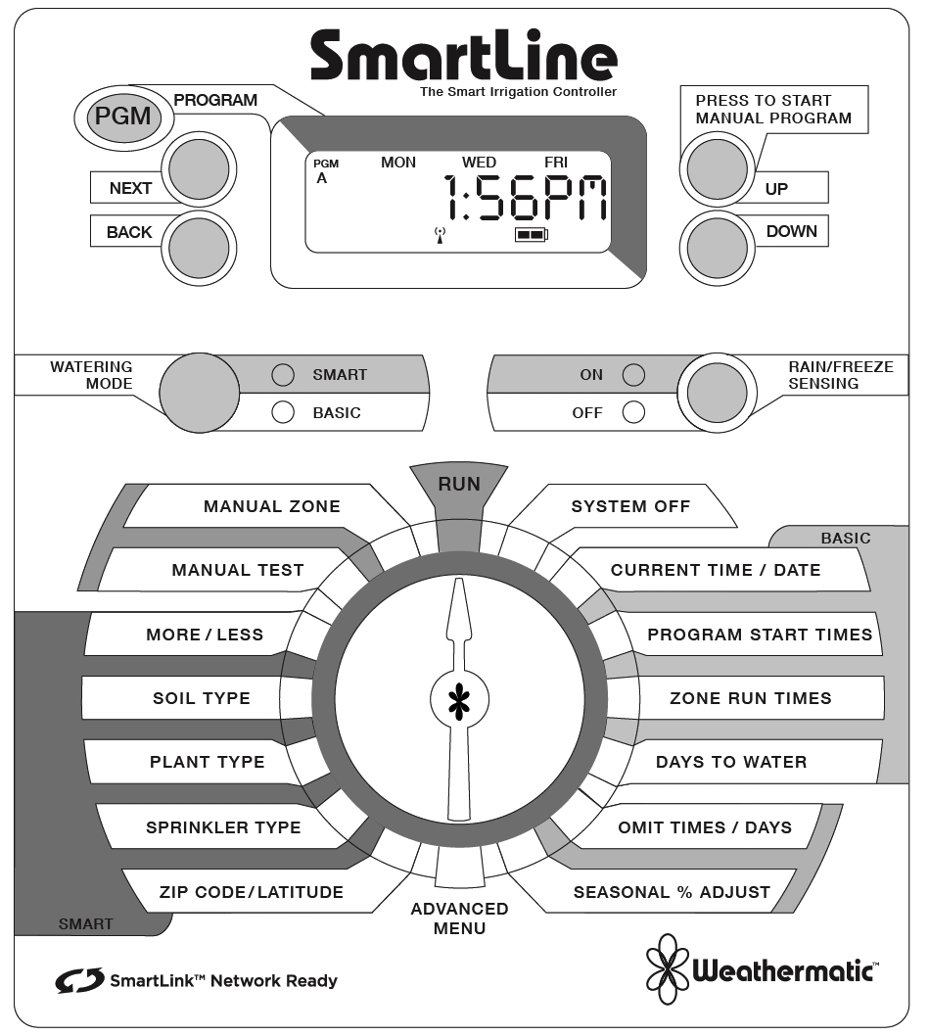

SmartLine® Weather Stations
SLW1
WEATHER STATION(S) shall be model SLW1 manufactured by Weathermatic Sprinkler Division of Telsco Industries. Weather stations must be compatible for use with SmartLine irrigation controls.
CONSTRUCTION: Weather station shall be wired in design using bi-directional communication. Weather station shall have integrated on-site sensors for rain-shut off, freeze shut-off and calculation of daily evapotranspiration irrigation deficits. Weather station shall have an integral mounting bracket with a two-point articulating arm made from high-impact molded resin. Weather station shall be suitable for outdoor mounting in light-commercial or residential environments. Weather station shall be capable of two-way communications with the SmartLine controls and have independent power supply, self-diagnostic circuit and microprocessor.
OPERATION: Weather stations rain sensor shall be adjustable to interrupt irrigation after a user selected precipitation amount of 1/8th”, 1/4” or 1/2”. Weather station shall be capable of interrupting irrigation after temperatures reach below 37 degrees Fahrenheit. Weather station shall provide instant notification to the controller of either a rain or freeze event and upon clearing of the same. Evapotranspiration deficits shall be calculated daily and transferred to the SmartLine controller each day.
WARRANTY: Weather station shall have a manufacturer’s limited warranty of two (2) years.
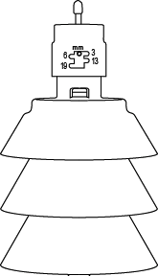

SmartLink™
Wireless Landscape Network
SMARTLINK: shall be model SL-AIRCARD1 as manufactured by Weathermatic Sprinkler Division of Telsco Industries. SL-AIRCARD1 is comprised of the SL-AIRCARD and SL-PLAN1for 1 year of service. Additional plans are available in 2, 3, 4, 5 and 10 year packages. Optional package to be available with flow monitoring.
CONSTRUCTION: SL-AIRCARD shall be housed in an indoor/outdoor housing. It shall incorporate an L.E.D. visible externally to indicate operating conditions of the SL-AIRCARD. The SL-AIRCARD shall be connected to the SmartLine Control, as manufactured by Weathermatic, through a cable from the SL-AIRCARD terminating in the SmartLine Control with the use of a plug-in RJ11 connector.
OPERATION: SL-AIRCARD communications protocol will be cellular (either GSM or CDMA) allowing connection through secure web based servers to smartlinknetwork.com.
SmartLink will not require software to be installed locally on a web-enabled appliance. Connection to SmartLink through the web will be through a web-enabled appliance such as a PC, Smart Phone, Tablet, etc.
SmartLink will not require software to be installed locally on a web-enabled appliance. User access to smartlinknetwork.com has password secured access to the users account.
Security to the account with access to individual sites and controllers is defined by the account administrator.
Each account will have the capability of unlimited users, sites and controllers.
At the controller page of SmartLink, the web user will be able to review, change or establish all programs available in the SmartLine Controller.
User defined names for Sites, Controllers, and individual zones will be available.
System/Controller/zone alerts will be sent to prescribed user by text or e-mail.
SmartLink will be enabled with Global Commands for complete/partial system control.
SmartLink will be enabled with AT-A-Glance Dashboard for easy review of SmartLine Controller parameters and manual watering operations.
WARRANTY: SL-AIRCARD shall have a manufacturer’s limited warranty of two (2) years. Optional Extended Warranty is to be available.

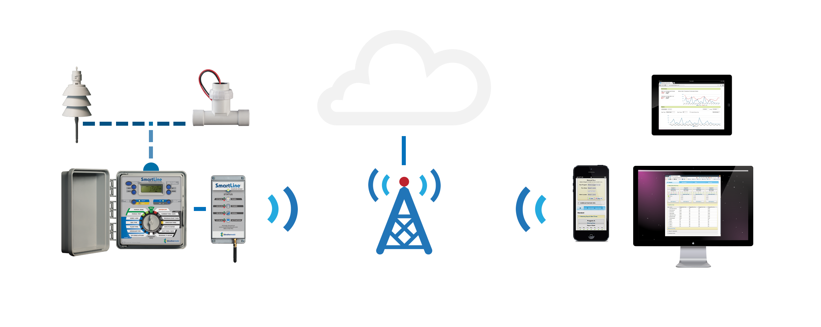
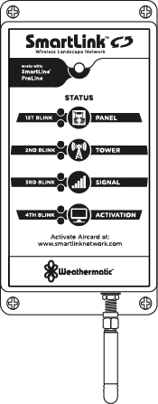

SmartLink® Flow Sensors
SLFSI-T or SLFSI-S
FLOW SENSOR(S) shall be model SLFSL-T or SLFSL-S manufactured by Creative Sensor Technology, Incorporated of Rochester, Massachusetts. The Model number shall include the Series designation followed by a three character group beginning with T (Tee Mounted) or S (Saddle Mounted) and followed by a two digit code referencing line size followed by a three digit electronic version designator. Therefore, the model number for a one inch size flow sensor with standard electronics would be written as: FSI-T10. Flow sensors must be compatible for use with SmartLine irrigation controls.
CONSTRUCTION: The flow sensor shall consist of a custom molded tee or saddle configured shaped body with socket ends conforming to PVC pipe dimensions, a flow sensor housing containing the electronic circuitry and carrying the spinning impeller and a retaining nut.
The meter body shall be an in line type available in 1", 1 1/2", 2”, 3” and 4” pipe sizes, molded from Rigid Polyvinyl Chloride material – color white (Tee Mounted) or color grey (Saddle Mounted) - conforming to ASTM D-1784, Cell Class 12454.
The 4 blade impeller (paddle wheel) shall be the only moving part.
The impeller shall be molded of HDPE (High Density Polyethylene) incorporating an integral bearing. The shaft material shall be tungsten carbide. These two items are considered wear items and shall be replaceable in the field without special tools.
The electronics housing, molded from the same material as the body shall be held in place with a single ACME threaded PVC retaining nut held captive by the wire leads. The housing will be sealed with one BUNA N O-Ring and shall be easily removed from the meter body. The electronics housing and tee body shall feature direction of flow arrows to assist in assembly.
The sensor electronics will be epoxy-sealed and fitted with 2 single conductors solid copper U.L. listed #18 AWG leads with direct burial insulation 48 inch in length extending from the top of the sensor. The positive (+) lead shall have red insulation and the negative (-) lead shall have black insulation.
The housing and mounting tee are custom molded to form an integrated measurement chamber resulting in highly accurate, repeatable flow measurements through a wide range of velocities.
The flow sensor shall be designed to schedule 40 specifications and have a tested working pressure of 240 psi @ 73°F (23°C). Maximum working temperature is 140°F (60°C).
The sensor flow range shall be 0.25 to 15 FPS.
The Product Serial Number shall be printed on shrink tubing and attached to the wire leads as they exit the top of the electronics housing.
The Product Model Number shall be printed on shrink tubing and attached to the wire leads above the Product Serial Number.
INSTALLATION and OPERATION: The flow sensor shall be installed with a minimum of 10 diameters of straight pipe upstream, and a minimum of 5 diameters of straight pipe downstream to eliminate irregular flow profiles caused by valves, fittings or pipe bends.
The flow senor shall be installed a valve box or meter pit of sufficient size to provide access to the flow sensor for service.
The installed sensor shall require a minimum clearance of approximately 4 inches (100 mm) above sensor for removal of the electronics housing.
Watertight Wire connections shall be made in the valve box using industry accepted methods and sealing products.
The maximum wire run between flow sensor and the controller shall be 2,000 feet if a 20/2 twisted pair shielded cable is used.
ELECTRICAL SPECIFICATIONS: The flow senor shall have an output Frequency Range of 0.3 Hz to 200 Hz.
The flow sensor shall output a minimum of a 5-millisecond low pulse at low frequencies and reverts to approximately a square wave above 100 Hz.
Quiescent current 600 uA@8 VDC to 35 VDC max.
On State (VLow) = Max. 1.2 VDC@50mA max.
WARRANTY: Flow sensors shall have a manufacturer’s limited warranty of five (5) years.

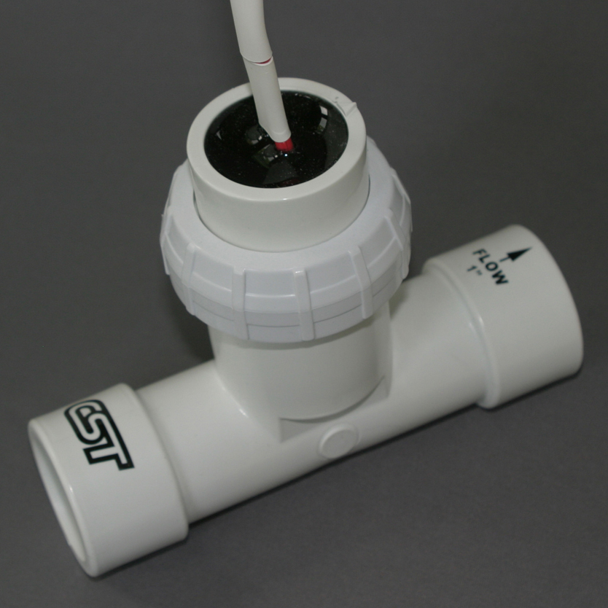

SmartLine® Controller Enclosure
SLPED-1600 / SLPED-4800

STAINLESS STEEL PEDESTALS shall be model SLPED-1600 (4800) as manufactured by Weathermatic Sprinkler Division of Telsco Industries.

CONSTRUCTION: Enclosures shall be fabricated from 16 gauge stainless steel with a brushed finish. A hinged stainless steel door shall be mounted to the front of the pedestal and include a cam style key-lock to restrict pedestal access. Pedestal base shall measure 10 ½” wide x 25” high x 3 ½” deep. A stainless steel pedestal cap and backplate shall be pre-assembled to the pedestal base to fit either the SL1600 (and SL1620 or SL1624) or SL4800 controller, as specified, with conduit holes and mounting hardware provided.

WARRANTY: Pedestals shall have a manufacturer’s limited warranty of two (2) years.

