SmartLine® Controllers
SL1600

SL1600 CONTROLLER(S) shall be model SL1600 as manufactured by Weathermatic Sprinkler Division of Telsco Industries, or approved equal. Controller(s) shall be a four (4) program controller with hot swappable 4-zone modules to allow expansion to 16 zones.

OPERATION: Controller shall be capable of standard timed watering or auto adjust watering times when equipped with an optional SLW weather monitor manufactured by Weathermatic. Auto Adjust watering shall be based on real time, on-site weather data and system audit data entered by the user. Auto adjust timing shall be based on the Hargreaves ET calculation formula. Controller shall provide reviewable watering deficits, scheduled run times by zone and a total run time recap for each zone which is resettable by the user. A more or less function shall be provided to allow run time adjustment by zone for shade/sunlight, system efficiency and other local factors. Auto adjust mode shall also include automatic calculation of run/soak times based on both soil type and zone elevation.

Each program shall have eight independent start times, calendar schedules, watering budgets by month and a soak/cycle for varying soil percolation rates.

Controller shall have a pump start/master valve position which shall be programmable to operate on demand from any selected zone. A programmable safety delay shall be included for zone to zone delay and master valve to zone delay for opening and closure.

Controller shall have input for rain and freeze sensor devices. Use of the optional SLW weather monitor shall incorporate the rain and freeze shutdown functions and shall incorporate a 48 hour delay after closure of the rain sense switch.

Controller shall have self-diagnostic capabilities to detect “short” or “open” zones and the ability to display lists of faults on an LCD display for the user. Diagnostics shall also include LCD display of volt/amp readings by zone and for transformer output as well as backup battery reading. A chatter function shall also be provided to assist in locating buried valves. The controller shall automatically prevent master valve opening or pump start when the valve locator diagnostic is used.

Display shall be backlit for clear viewing in all lighting conditions. Zone timing shall be settable from 1 minute to 9 hours and 55 minutes.

Program D shall operate concurrently with programs A, B and C. Programs A, B and C shall stack in sequence of start time operation.

Program schedules shall include options for days of the week, odd date, even date or an interval of 1 to 30 days. A ‘no water’ window shall be available to inhibit daily operations of a program between two selected times on a given day; omission of up to 7 specified calendar dates or specific days of the week. Adjustments for leap year shall be automatic.

Manual operation shall be provided by program, by station, or on a programmable test program with durations from ten (10) seconds to ten (10) minutes. The programmable test program shall also check for short and open conditions on each zone each time it is run.

Non-volatile memory shall retain all programming and real-time clock shall be provided to maintain date and time.

CONSTRUCTION: Controller shall be enclosed in a U.L., CE and C-Mark Listed rainproof plastic enclosure with optional key lock. The enclosure shall be rated for outdoor or indoor use. Enclosure shall be a wall mount (pedestal mount) model with removable knockouts on the lower side and back of the housing for choice of wiring location. The operating panel shall be a totally enclosed module that is removable from the housing for programming at a separate location. A test post for 24V a.c. operation shall be accessible with or without the operating panel. Zone modules (SLM4) shall be self-contained modules that can be installed without turning off power to the unit and programming of new zones shall not be required. Module wiring connections shall be of the type that allows insertion of solid wires without any tool. Each module shall contain its own surge protection.

ELECTRIC: Controller shall be completely electric in operation. Controller shall be installed and wired in accordance with manufacturer’s published instructions. Controller shall be capable of operating from an independent power supply. Primary shall be 115V a.c. 60hz or 230V, 50hz.

WARRANTY: Controller shall have a manufacturer’s limited warranty of three (3) years.
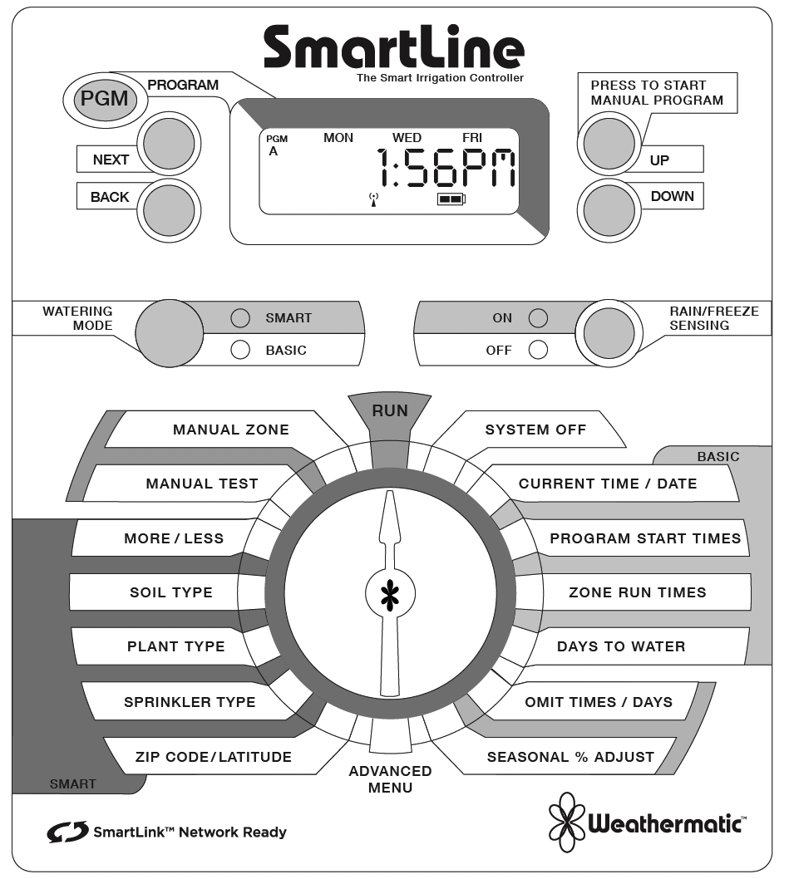

SmartLine® Weather Stations
SLW1
WEATHER STATION(S) shall be model SLW1 manufactured by Weathermatic Sprinkler Division of Telsco Industries. Weather stations must be compatible for use with SmartLine irrigation controls.
CONSTRUCTION: Weather station shall be wired in design using bi-directional communication. Weather station shall have integrated on-site sensors for rain-shut off, freeze shut-off and calculation of daily evapotranspiration irrigation deficits. Weather station shall have an integral mounting bracket with a two-point articulating arm made from high-impact molded resin. Weather station shall be suitable for outdoor mounting in light-commercial or residential environments. Weather station shall be capable of two-way communications with the SmartLine controls and have independent power supply, self-diagnostic circuit and microprocessor.
OPERATION: Weather stations rain sensor shall be adjustable to interrupt irrigation after a user selected precipitation amount of 1/8th”, 1/4” or 1/2”. Weather station shall be capable of interrupting irrigation after temperatures reach below 37 degrees Fahrenheit. Weather station shall provide instant notification to the controller of either a rain or freeze event and upon clearing of the same. Evapotranspiration deficits shall be calculated daily and transferred to the SmartLine controller each day.
WARRANTY: Weather station shall have a manufacturer’s limited warranty of two (2) years.
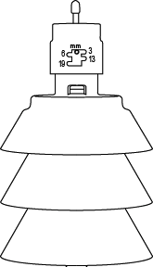

SmartLine® Controller Enclosure
SLPED-1600 / SLPED-4800

STAINLESS STEEL PEDESTALS shall be model SLPED-1600 (4800) as manufactured by Weathermatic Sprinkler Division of Telsco Industries.

CONSTRUCTION: Enclosures shall be fabricated from 16 gauge stainless steel with a brushed finish. A hinged stainless steel door shall be mounted to the front of the pedestal and include a cam style key-lock to restrict pedestal access. Pedestal base shall measure 10 ½” wide x 25” high x 3 ½” deep. A stainless steel pedestal cap and backplate shall be pre-assembled to the pedestal base to fit either the SL1600 (and SL1620 or SL1624) or SL4800 controller, as specified, with conduit holes and mounting hardware provided.

WARRANTY: Pedestals shall have a manufacturer’s limited warranty of two (2) years.

